**E-LEARNING WEBSITE**

A

Project report submitted to



UTKAL UNIVERSITY , Bhubaneswar , Odisha

in partial fulfillment of the requirements for

the award of the degree of

Bachelor of Science in

COMPUTER SCIENCE (HONs)

At - Royal College of Science & Technology

**By-Sarthak Ranjan Hota**

(regd.no: 1702010490560025)

Under the guidance of

Mr. Dilip Narayan Sahu

 Lecturer, Department of Computer Science

**ROYAL COLLEGE OF SCIENCE AND TECHNOLOGY, BHUBANESWAR**



DEPARTMENT OF COMPUTER SCIENCE

UTKAL UNIVERSITY, ODISHA



**CERTIFICATE**

This is to certify that the thesis entitled “E-LEARNING WEBSITE” submitted by Sarthak Ranjan Hota, Registration number 1702010490560025, in partial fulfillment of the requirements for the degree of Bachelor of Science, during session 2017-20 in the department Computer science of Utkal University, is a bona fide work carried out by him under my supervision and guidance.

We hereby accord our approval of it as a dissertation work carried out and presented in a manner required for its acceptance for the partial fulfillment for the award of degree of Bachelor of Science in Computer Science, for which it has been submitted. The approval does not necessarily endorse or accept every statement made, opinion expressed or conclusions drawn as recorded in this thesis. It only signifies the acceptance of the thesis for the purpose it has been submitted.

***Mr. Dillip Narayan Sahu******Mr. Jiban Kishore Mishra***

***Project Guide Head of the Department***

***Dr. Prasanta Kumar Nath***

***Principal***

**(***External Examiner) (Internal Examiner)*

**Declaration**

***This is to certify that the project report entitled “E-LEARNING WEBSITE “Which is submitted by me in partial fulfilment of the requirement for the award of the degree, Bachelor Of Science in Computer Science Honours, Royal College Of Science And Technology, Bhubaneswar ,Odisha affiliated Under Utkal University, Bhubaneswar, Odisha ,comprises only my original work and due acknowledgment has been made in the text to all material used. It has not been previously presented in this institution to the best of my knowledge.***

***Sarthak Ranjan Hota***

***Regd.no:1702010490560025***

***Royal College of Science and Technology***

Acknowledgement

***We take this occasion to thank God, almighty for blessing us with his grace and taking our endeavor to a successful culmination. We extend our sincere and heartfelt thanks to our esteemed guide, Mr. Dillip Narayan Sahu , for providing us with the right guidance and advice at the crucial junctures and for showing me the right way. We also take this opportunity to express a deep sense of gratitude to our class coordinators for their cordial support, valuable suggestions and guidance. We extend our sincere thanks to our respected Principal Dr. Prasant Kumar Nath and Head of the department Mr. Jiban kishor mishra , for allowing us to use the facilities available. We would like to thank the other faculty members also, at this occasion. Last but not the least, we would like to thank our friends and family for the support and encouragement they have given us during the course of our work***.

#### ABSTRACT

***This project is based on E-Learning website. It contains the programming language.Education is an aspect of socialization which involves the acquisition of knowledge and learning of skills. In an era known as the society of technology and knowledge, where lifelong learning is a way of life, it is important that educational institutions have as a priority the goal of finding effective ways of providing new learning opportunities according to their environment, student characteristics, teacher training, economic crisis and advancing technology in an effort to make learning more efficient, equitable and innovative in higher education. At Guarda Polytechnic Institute, Portugal (IPG), we recognize the need and the opportunities to create and develop new e-education courses (e-Learning, blended learning, mobile learning) in order to engage and motivate students according to their necessities. Thus, we have, in this last decade, developed and implemented a set of institutional objectives with regard to teaching electronic courses which aim to provide intuitive content courses online, easy to access anywhere in any place***.

**Key Words:**

***Html , Javascript, CSS , Browser, Xampp ,mysql ,php***

## TABLE OF CONTENTS

ABSTRACT

1. INTRODUCTION---------------------------------------------1
   1. PROJECT AIMS AND OBJECTIVES------------------------**3**
   2. BACKGROUND OF PROJECT-----------------------------**3**
2. PROJECT DESCRIPTION--------------------------------4

###### GENERAL DESCRIPTION---------------------------------4

* 1. MAIN MODULE OF THE PROJECT-------------------------**4**
  2. LANGUAGE USED IN PROJECT---------------------------**5**

1. WEB DIAGRAM OF THE WEBSITE-----------------------7
2. DATABASE DIAGRAM----------------------------------8
3. WEBSITE DESIGN------------------------------------- 10

###### FRONT END-------------------------------------------15

###### BACK END--------------------------------------------18

1. CODING OF THE WEBSITE----------------------------20
2. CONCLUSION ---------------------------------------63
3. REFERENCE ----------------------------------------64

CHAPTER-1

**INTRODUCTION**

The increased need for teacher adaptability, according to student characteristics in the use of technologies has important implications for the future of education, training and competitiveness of schools .Ubiquitous technology and Web 2.0 tools play today a fundamental key role in promoting technology-enhanced learning and creating new learning concepts and new opportunities in the field of learning. It is clear that the concept of learning has penetrated the walls of schools generating a number of concepts as e-learning, blended learning and mobile learning. Teachers and students are no longer located physically on a school campus. This new world allows for creative and collaborative participation in the process of learning. As daily consumers, as teachers, and as students we all recognize that technologies are increasingly being used in society and in the economy, and this is transforming ways of working, studying (lifelong learning), communicating, accessing information and spending leisure time, among others. Several studies, conducted in this last decade have shown that the evolution of the World Wide Web and ICT could enable creative and innovative practices in schools. The value of information offered at Web sites, can enhance students' research, developing new skills and new methodologies to be critical users of the Web and the Internet, thus playing an important role in education. Learning should be reflective of underlying social environments. The evolution of the World Wide Web driven by usergenerated content represents a new form of collaboration and communication creating new tools such as platforms, blogs, podcast and wikis. Web 2.0 means a qualitative leap in Web technologies that has made the internet more creative, participative and socializing .Research evidence suggests that these online tools, web technologies, have not only affected people’s private and professional lives, but are also starting to transform learning patterns and pathways, and also demonstrated the benefits of applying these technologies to learning .In this context, several authors have defined and introduced new terms such as Learning 2.0 , Web-based learning or Internet-based instruction to relate to a learning-teaching process that takes places with the use of ICT and Web 2.0 tools.

Another important point is related to the fact that today’s students have always been surrounded by, and interacted with, new technologies. Marc Prensky defends that students have changed radically and are no longer the people our educational system was designed to teach, calling them Digital Natives. But other authors with this perspective have also defined actual students as Net Generation learners or New Millennium Learners. In a general perspective, all these authors defend that students are highly dependent on technology and use technology extensively to network and socialize. These characteristics have an effect on the way students build their identities, communicate socially, and manage information and knowledge. All this new technology has strong implications for the teaching-learning process by changing the ways in which knowledge is transmitted, acquired and handled. Recent investigations have shown clear evidence about the changes occurring in the last decade with respect to changing the paradigms of learning, attitudes, learning styles and patterns. Learning in the digital era is fundamentally collaborative and aims to facilitate the learning process by providing social and cognitive guidance and support. Today the learner plays a central role in the learning process as an active author, co-creator, evaluator and critical commentator. In this context researchers have proposed various approaches to develop adaptive learning systems based on the personal features, characteristics, or learning behaviors of students to improve learning efficiency.

This overview about the aim, objectives, background of the system.

#### PROJECT AIMS AND OBJECTIVES

The objectives of the E-Learning website are –

1. **Career advancement and hobbies**.
2. **Flexible schedule and environment**.
3. **More choice of course topics.**
4. **Lower costs and debts.**

#### BACKGROUND OF PROJECT

This Educational website project developed using specific programming languages. The main aim of this project is to develop an online website which covers all the subject related to education like programming languages such as php,html,java,bootstrap etc. The proposed of website is to make a better experience in education through out by website and anyone can learn with out any cost.

**CHAPTER 2**

**PROJECT DESCRIPTION**

###### GENERAL DESCRIPTION:

**Present State:**

 No Software present at all.

Difficult to Learn about any topic.

More time taken to understand the topic.

**After implementation of project:**

Easy to study.

Free Registration.

Good quality of Education.

Provide different fields of education.

High productivity.

More comfortable to study in any time.

**Main Modules of the Project**

**1)Welcome Page**: -

This page can welcome the user and started the journey to inside the main page of the website.

**2)Homepage: -**

In this page user can be use the all the elements of the website, The website provides all the computational courses. All the webpages linked with the homepage so user can access all the service provides by the site.

**3)Courses pages:-**

This page includes all the course available in website, there are several courses present in the website e.g : Java, C, C++, JavaScript etc, in this pages briefly described about the courses like when it was created, created by who and also the course pages holds the information about the topic provides download option for the users.

**4)Notification page: -**

The Notification page shows all the notification about the website, here it notify the users what are the latest courses are added to the page and it’s syllabus, it also add the upcoming event which are useful for the users.

**5)Contact Us page:-**

Here the users can give the feedback about the website ,which are help for the administrator for developing of the website.The users can give the suggestions of the website where they can take advantages of the website and also suggest the administrator what course users need.

**LANGUAGE USED IN PROJECT:-**

**1) TECHNOLOGY PHP:**

Hypertext preprocessor is a server-side scripting language designed for web development, but also used as general-purpose programming language. It was created in 1994, itis now produced by PHP group. It can interact with many database languages including MySQL.

**2) HTML: HTML**

is a hypertext markup language which is, in reality, a spinal cord of any website. Any website can’t be structured without the knowledge of HTML. If we make our web page only with the help of HTML, then we can’t add many of the effective features in a web page, for making a web page more effective we use various platforms such as static and dynamics methods. And here we are using this language to make our web pages more effective as well as interactive for users to understand. And to make our web pages dynamic we are using JavaScript and XML.

**3) CSS:**

CSS in PHP Stands for (Cascading Style Sheet). Cascading style sheets are used to format the layout of Web pages. They can be used to define way of writing or style, size of various table, and other aspects of Web pages that previously could only be defined in a static page's HTML. The main work of CSS is to separate content of a web document that is written using Cascading Style Sheets. There are lots of benefits that one can extract through this like improved content accessibility, better flexibility and moreover, and hence gives a level of control over various presentation characteristics of the document. It also helps in reducing the problems and helps in saving access time. It gives the option of selecting various style schemes and rules according to the necessity.

**4) JAVASCRIPT:**

JavaScript is the most famous scripting languages of all time. JavaScript is a Scripting Language of World Wide Web. The main usage of JavaScript is to add various Web function, validations, detections, a creation of cookies and so on. JavaScript is the best scripting languages and that is why it is adopted by almost all browsers. JavaScript is considered the most powerful scripting languages in present use. It is used for the client -side web development. JavaScript is used to make pages more interactive. It is a light-weight programming language and it is embedded directly into the markup syntax. JavaScript, as the name defines, was affected by many languages, especially Java.

**CHAPTER-3**

**WEB DIAGRAM OF THE WEBSITE**

**SUMBIT**

**CONTACT US**

**Related post**

**Notification**

**FOLLOW US**

**DOWNLOAD COURSES**

**COURSES PAGE**

**HOMEPAGE**

**WELCOME PAGE**

# WEB DIAGRAM:-

Web diagrams are useful tools when you need to step back and look at the broad picture. Whether you're planning a website, a Web app or any other complex system or set of ideas, a Web diagram illustrates the relationships between objects and can show shortcomings in your plan. a Web diagram is primarily a visual aid, limit the diagram labels to two or three words and use shapes and colors to identify components of the diagram. The definition of a diagram is a graph, chart, drawing or plan that explains something by showing how the parts relate to each other.

**CHAPTER-4**

**DATABASE DESIGN**

**Steps for connecting database:-**

First of all in this website contactus page is connect to the Database.

**Step1:** First we have to install xampp server & MySQL server.

**Step2**: Then open xampp server and start apache and mysql server.

**Step3**: Then open any browser and write <http://localhost/phpmyadmin/> on the search tab.

**Step4**: Then create a new database name as **contactus** and set number of column 4.

**Step5**:And the column name as Name, Email ,phone,comments.

**Table design:**

|  |  |  |  |
| --- | --- | --- | --- |
| **Field** | **Data Type** | **Default** | **Length** |
| name | VARCHAR | NULL | 20 |
| email | VARCHAR | NULL | 20 |
| phone | INT | NULL | 10 |
| comments | VARCHAR | NULL | 160 |

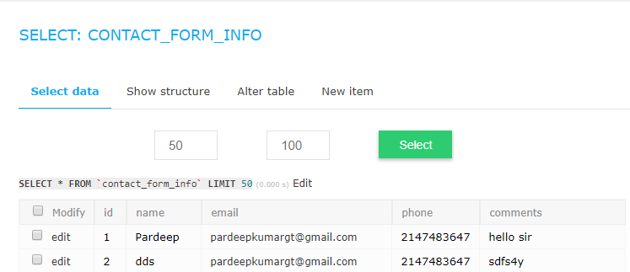**Result:**

**CHAPTER-5**

**WEBSITE DESIGN**

**1)Welcome page:**

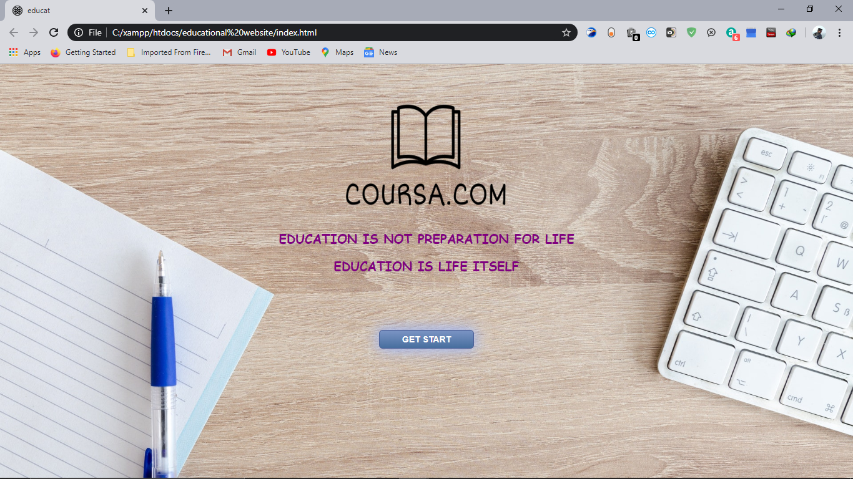

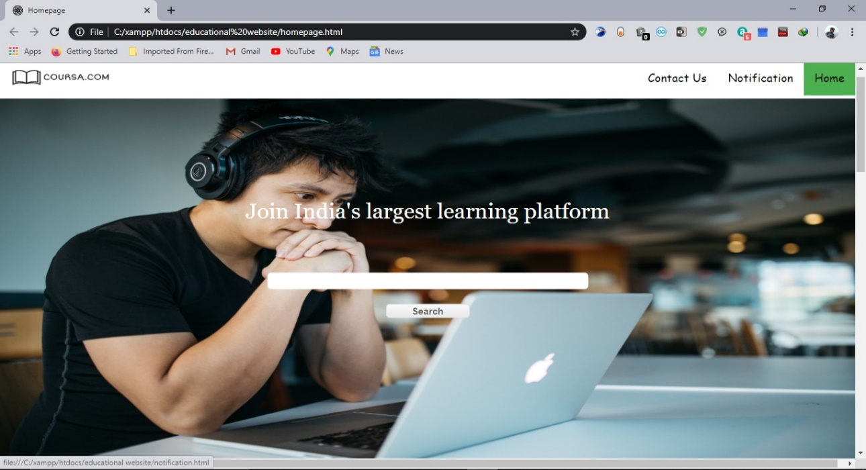**2)Homepage:**

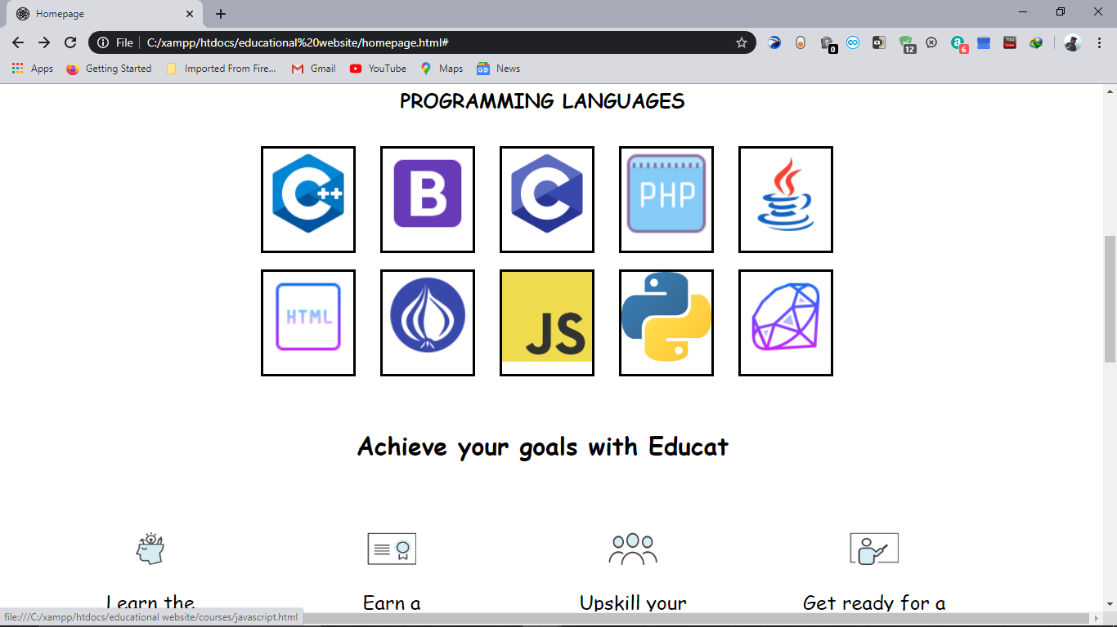

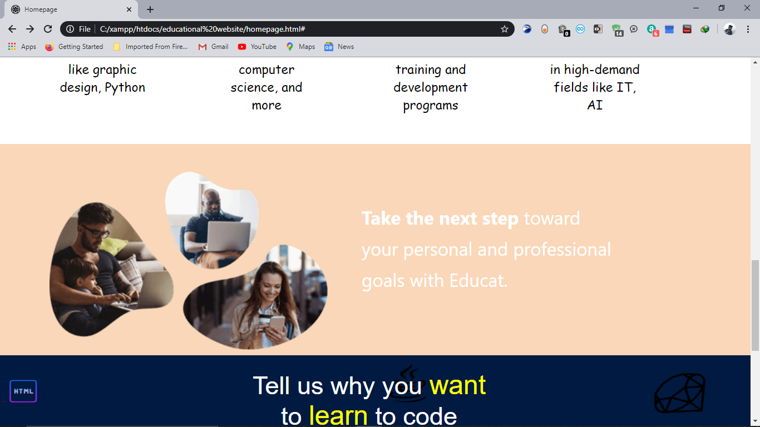

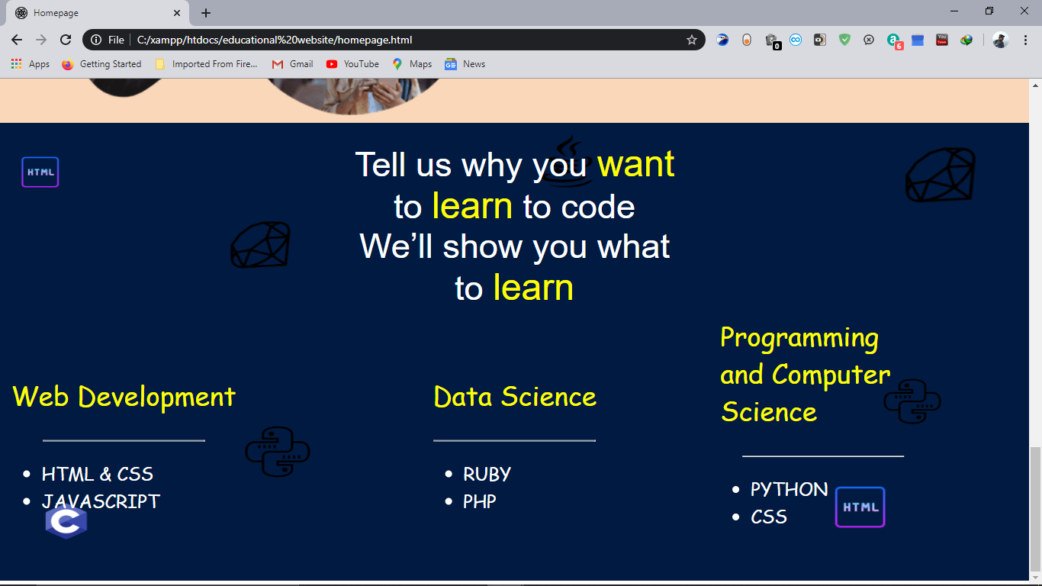Here is our homepage of the website , the website name is **COURSA.COM .**the home page provides you all courses available in website and also there is a search bar where you can search any courses. On the top of the home page you can find the contact us button for contact to the administrator of the website.

**3)Courses page:**

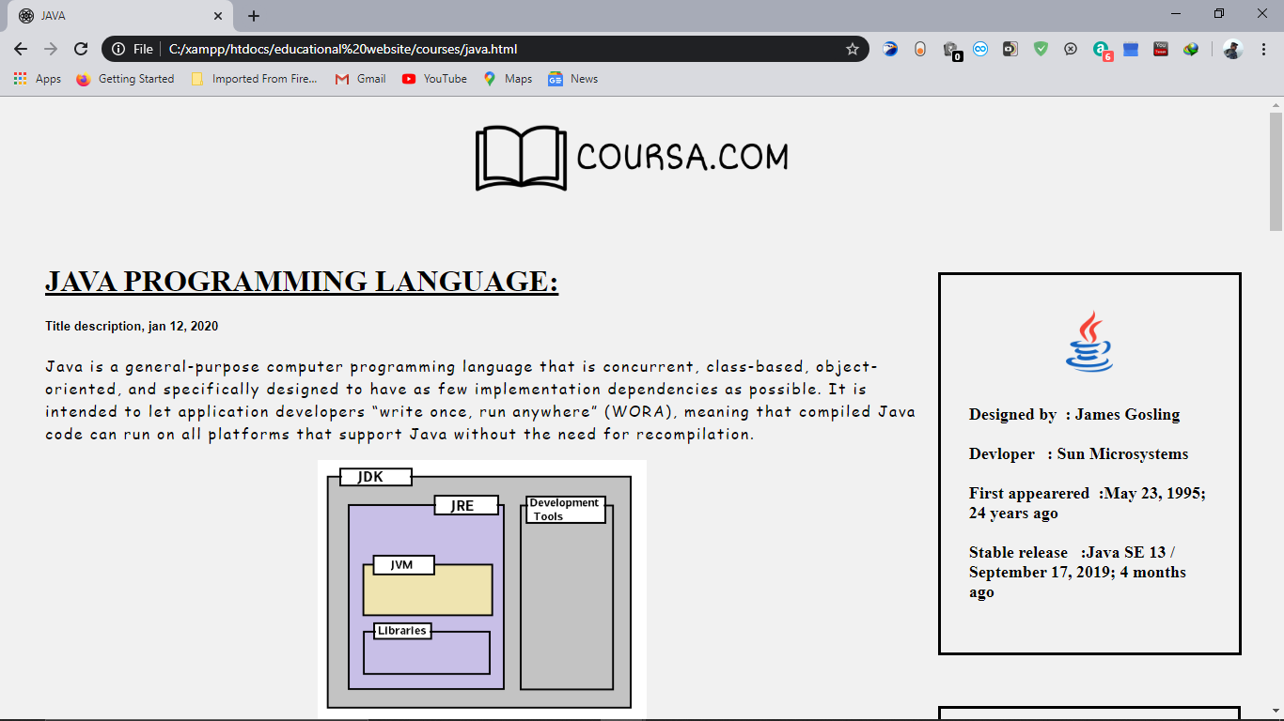

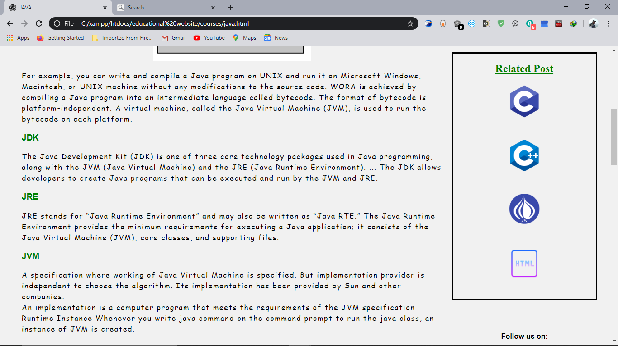`

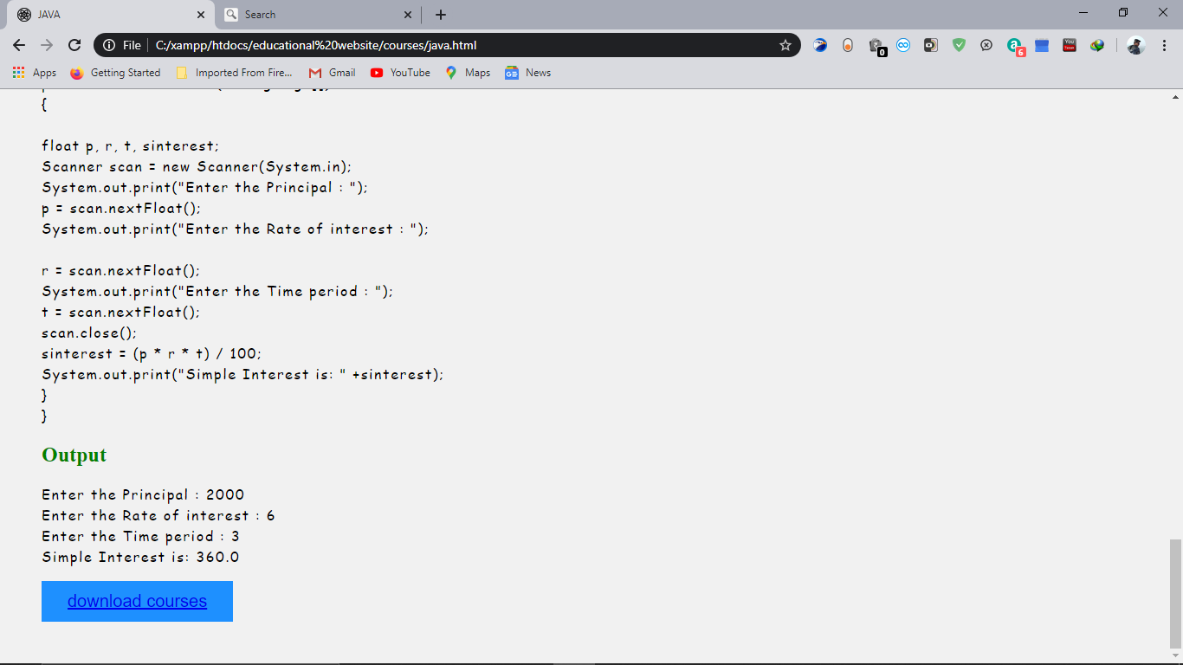

This page includes all the course available in website, there are several courses present in the website e.g : Java, C, C++, JavaScript etc, in this pages briefly described about the courses like when it was created, created by who and also the course pages holds the information about the topic provides download option for the users.

**4)Notification Page:**

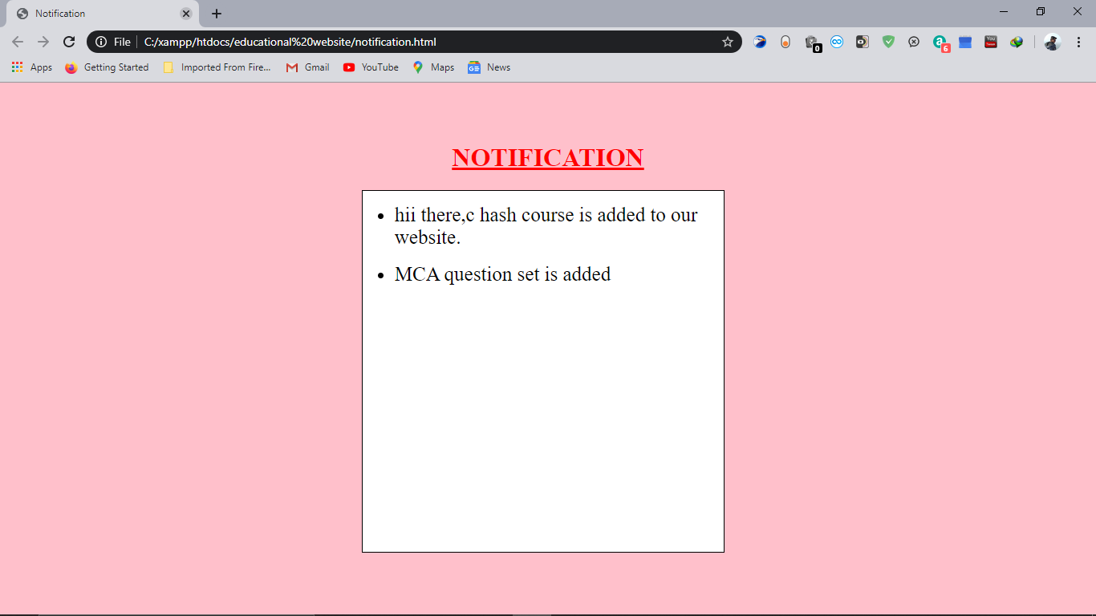

The Notification page shows all the notification about the website, here it notify the users what are the latest courses are added to the page and it’s syllabus, it also add the upcoming event which are useful for the users.

#### 5)Contact Us:

#### 

#### z

**FRONT END**

The front end is designed using of html , Php ,css, Java script.

* HTML- **HTML** or **Hyper Text Markup Language** is the main markup language for creating web pages and other information that can be displayed in a web browser.HTML is written in the form of HTML elements consisting of *tags* enclosed in angle brackets (like <html>), within the web page content. HTML tags most commonly come in pairs like <h1> and </h1>, although some tags represent *empty elements* and so are unpaired, for example <img>. The first tag in a pair is the *start tag*, and the second tag is the *end tag* (they are also called *opening tags* and *closing tags*). In between these tags web designers can add text, further tags, comments and other types of text-based content. The purpose of a web browser is to read HTML documents and compose them into visible or audible web pages. The browser does not display the HTML tags, but uses the tags to interpret the content of the page.HTML elements form the building blocks of all websites. HTML allows images and objects to be embedded and can be used to create interactive forms. It provides a means to create structured.documents by denoting structural semantics for text such as headings, paragraphs, lists, links, quotes and other items. It can embed scripts written in languages such as JavaScript which affect the behavior of HTML web pages.
* CSS- **Cascading Style Sheets** (**CSS**) is a style sheet language used for describing the look and formatting of a document written in a markup language. While most often used to style web pages and interfaces written in HTML and XHTML, the language can be applied to any kind of XML document, including plain XML, SVG and XUL. CSS is a cornerstone specification of the web and almost all web pages use CSS style sheets to describe their presentation.CSS is designed primarily to enable the separation of document content from document presentation, including elements such as the layout, colors, and fonts. This separation can improve content accessibility, provide more flexibility and control in the specification of presentation characteristics, enable multiple pages to share formatting, and reduce complexity and repetition in the structural content (such as by allowing for table less web design).CSS can also allow the same markup page to be present in different styles for different rendering methods, such as on-screen, in print, by voice (when read out by a speech-based browser or screen reader) and on Braille-based, tactile devices. It can also be used to allow the web page to display differently depending on the screen size or device on which it is being viewed. While the author of a document typically links that document to a CSS file, readers can use a different style sheet, perhaps one on their own computer, to override the one the author has specified. However if the author or the reader did not link the document to a specific style sheet the default style of the browser will be applied.CSS specifies a priority scheme to determine which style rules apply if more than one rule matches against a particular element. In this so-called *cascade*, priorities or *weights* are calculated and assigned to rules, so that the results are predictable.
* JAVA SCRIPT- **JavaScript** (**JS**) is a dynamic computer programming language. It is most commonly used as part of web browsers, whose implementations allow client-side scripts to interact with the user, control the browser, communicate asynchronously, and alter the document content that is displayed. It is also being used in server-side programming, game development and the creation of desktop and mobile applications. JavaScript is a prototype-based scripting language with dynamic typing and has first- class functions. Its syntax was influenced by C. JavaScript copies many names and naming conventions from Java, but the two languages are otherwise unrelated and have very different semantics. The key design principles within JavaScript are taken from the Self and Scheme programming languages. It is a multi- paradigm language, supporting object-oriented, imperative,and functional programming styles. The application of JavaScript to use outside of web pages—for example, in PDF documents, site-specific browsers, and desktop widgets—is also significant. Newer and faster JavaScript VMs and platforms built upon them (notably Node.js) have also increased the popularity of JavaScript for server-side web applications. On the client side, JavaScript was traditionally implemented as an interpreted language but just-in-time compilation is now performed by recent (post-2012) browsers.
* PHP- **PHP** is a server-side scripting language designed for web development but also used as a general-purpose programming language. PHP is now installed on more than 244 million websites and 2.1 million web servers. Originally created by Rasmus Lerdorf in 1995, the reference implementation of PHP is now produced by The PHP Group. While PHP originally stood for *Personal Home Page*, it now stands for *PHP: Hypertext Preprocessor*, a recursive backronym.PHP code is interpreted by a web server with a PHP processor module, which generates the resulting web page: PHP commands can be embedded directly into an HTML source document rather than calling an external file to process data. It has also evolved to include a command-line interface capability and can be usedin standalone graphical applications. PHP is free software released under the PHP License. PHP can be deployed on most web servers and also as a standalone shell on almost every operating system and platform, free of charge.
  + 1. **BACK END**

The back end is designed using mysql which is used to design the databases

* MYSQL- **MySQL** ("My S-Q-L", officially, but also called "My Sequel") is (as of July 2013) the world's second most widely used open-source relational database management system (RDBMS). It is named after co-founder Michael Widenius daughter, My. The SQL phrase stands for Structured Query Language. The MySQL development project has made its source code available under the terms of the GNU General Public License, as well as under a variety of proprietary agreements. MySQL was owned and sponsored by a single for- profit firm, the Swedish company MySQL AB, now owned by Oracle Corporation .MySQL is a popular choice of database for use in web applications, and is a central component of the widely used LAMP open source web application software stack (and other 'AMP' stacks). LAMP is an acronym for "Linux, Apache ,MySQL, Perl/PHP/Python." Free-software-open source projects that require a full-featured database management system often use MySQL. For commercial use, several paid editions are available, and offer additional functionality. Applications which use MySQL databases include: TYPO3, MODx, Joomla, WordPress, phpBB, MyBB, Drupal and other software. MySQL is also used in many high-profile, large-scale websites, including Wikipedia, Google (though not forsearches), Facebook, Twitter, Flickr, and YouTube.

• PHP: Hypertext preprocessor is a server-side scripting language designed for web development, but also used as general-purpose programming language. It was created in 1994, itis now produced by PHP group. It can interact with many database languages including MySQL**.**

**CHAPTER-6**

**CODING OF THE WEBSITE**

**1)welcome page :-**

First we have to create a html file name **index.html ,**where css & html code are written.

**Index.html**

<!DOCTYPE html>

<html>

<head>

<style>

body {

background-image: url(background.jpg);

background-repeat: no-repeat;

background-size: cover;}

img {

padding: 0px;

width: 500px; }

body {

background-color: white;}

h1

{

font-family: Helvetica;

font-size: 35px;}

h2{

font-family: Comic Sans MS;

font-size: 20px;

color: #800080;}

button {

color: #444444;

background: #F3F3F3;

border: 1px #DADADA solid;

padding: 5px 10px;

border-radius: 4px;

font-weight: bold;

font-size: 9pt;

outline: none;}

.myButton {

-moz-box-shadow: 0px 0px 22px 3px #9fb4f2;

-webkit-box-shadow: 0px 0px 22px 3px #9fb4f2;

box-shadow: 0px 0px 22px 3px #9fb4f2;

background:-webkit-gradient(linear, left top, left bottom, color-stop(0.05, #7892c2), color-stop(1, #476e9e));

background:-moz-linear-gradient(top, #7892c2 5%, #476e9e 100%);

background:-webkit-linear-gradient(top, #7892c2 5%, #476e9e 100%);

background:-o-linear-gradient(top, #7892c2 5%, #476e9e 100%);

background:-ms-linear-gradient(top, #7892c2 5%, #476e9e 100%);

background:linear-gradient(to bottom, #7892c2 5%, #476e9e 100%);

filter:progid:DXImageTransform.Microsoft.gradient(startColorstr='#7892c2', endColorstr='#476e9e',GradientType=0);

background-color:#7892c2;

-webkit-border-radius:6px;

-moz-border-radius:6px;

border-radius:6px;

border:1px solid #4e6096;

display:inline-block;

cursor:pointer;

color:#ffffff;

font-family:Arial;

font-size:14px;

font-weight:bold;

padding:6px 36px;

text-decoration:none;

text-shadow:0px 0px 0px #283966;

}

.myButton:hover {

background:-webkit-gradient(linear, left top, left bottom, color-stop(0.05, #476e9e), color-stop(1, #7892c2));

background:-moz-linear-gradient(top, #476e9e 5%, #7892c2 100%);

background:-webkit-linear-gradient(top, #476e9e 5%, #7892c2 100%);

background:-o-linear-gradient(top, #476e9e 5%, #7892c2 100%);

background:-ms-linear-gradient(top, #476e9e 5%, #7892c2 100%);

background:linear-gradient(to bottom, #476e9e 5%, #7892c2 100%);

filter:progid:DXImageTransform.Microsoft.gradient(startColorstr='#476e9e', endColorstr='#7892c2',GradientType=0);

background-color:#476e9e;

}

.myButton:active {

position:relative;

top:1px;

}</style>

<center><img src="C:\xampp\htdocs\educational website\img\logo4.png" style="width: 300px;height: 200px;"></center>

<link rel="stylesheet" type="text/css" href="style.css">

<title>educat</title>

<link rel="shortcut icon" type="image/png" href="C:\xampp\htdocs\educational website\img\logo2.png">

</head>

<body>

<div class="logo"><a href="C:\xampp\htdocs\educational website\img\logo4.png"></a>

</div>

<CENTER><h2>EDUCATION IS NOT PREPARATION FOR LIFE</h2>

<h2>EDUCATION IS LIFE ITSELF</h2>

<br>

<br><br><br>

<a href="homepage.html" class="myButton">GET START</a>

</CENTER>

</body>

</html>

**2)Homepage:-**

This page is saved as homepage.html

**Homepage.html**

<!DOCTYPE html>

<html>

<head>

<style type="text/css">

body{

background: white;

margin: 0px;

padding: 0px;

}

.container {

width:700px;

height:0px;

padding-top:20px;

padding-left:330px;

padding-right:5px; }

#st-box {

float:left;

width:110px;

height:125px;

background-color:white;

border:solid black; }

#nd-box {

float:left;

width:110px;

height:125px;

background-color:white;

border:solid black;

margin-left:30px; }

#rd-box {

float:left;

width:110px;

height:125px;

background-color:white;

border:solid black;

margin-left:30px;

margin-bottom: 20px;}

#fo-box {

float:left;

width:110px;

height:125px;

background-color:white;

border:solid black;

margin-left:30px;

margin-bottom: 20px;}

#th-box {

float:left;

width:110px;

height:125px;

background-color:white;

border:solid black;

margin-right: 0px;}

#sth-box {

float:right;

width:110px;

height:125px;

background-color:white;

border:solid black;

margin-left:30px; }

#sv-box {

float:left;

width:110px;

height:125px;

background-color:white;

border:solid black;

margin-left: 30px;}

#et-box {

float:left;

width:110px;

height:125px;

background-color:white;

border:solid black;

margin-left: 30px;

}

#ni-box {

float:left;

width:110px;

height:125px;

background-color:white;

border:solid black;

margin-left: 30px;}

nav{

position: absolute;

}

nav.logo{

padding: 0px 0px;

height: 25px;

float:left;

margin-left: 0px;

}

#et-box {

float:left;

width:110px;

height:125px;

background-color:white;

border: solid black;

margin-left: 30px;

}

.center{

position: absolute;

top: 60%;

left: 50%;

transform: translate(-50%, -50%);

}

.title {

background-color: transparent;

color: white;

margin: 5px;

padding: 5px;

width: 180px;

height:300px;

float:left;

margin-left: 100px;}

.spring {

background-color: #fad7b9;

color: white;

margin: 0px;

padding: 50px;

width: 1260px;

height:280px;

float:left;

}

.summer{

position: relative;

}.myButton {

box-shadow:inset 0px 1px 0px 0px #ffffff;

background:linear-gradient(to bottom, #f9f9f9 5%, #e9e9e9 100%);

background-color:#f9f9f9;

border-radius:6px;

border:1px solid #dcdcdc;

display:inline-block;

cursor:pointer;

color:#666666;

font-family:Arial;

font-size:15px;

font-weight:bold;

padding:2px 40px;

text-decoration:none;

text-shadow:0px 1px 0px #ffffff;

}

.myButton:hover {

background:linear-gradient(to bottom, #e9e9e9 5%, #f9f9f9 100%);

background-color:#e9e9e9;

}

.myButton:active {

position:relative;

top:1px;

}

.centered {

position: absolute;

top: 66%;

left: 50%;

transform: translate(-50%, -50%);}

.left {

position: absolute;

top: 80%;

left: 12%;

transform: translate(-50%, -50%);}

li{

line-height: 1.5em;}

.under {

position: absolute;

top: 80%;

left: 50%;

transform: translate(-50%, -50%);}

.right {

position: absolute;

top: 80%;

left: 80%;

transform: translate(-50%, -50%);}

body, html{

height: 100%;

padding: 0;

margin: 0;

font-family: 'Sniglet', cursive;

}h1{

font-weight: normal;

font-size: 4em;

font-family: 'Raleway', sans-serif;

margin: 0 auto;

margin-top: 30px;

width: 500px;

color: #F90;

text-align: center;}

.navbar {

width: 100%;

background-color: transparent;

overflow: auto;

float:right;

}.navbar a{

float: left;

padding: 17px;

color: black;

text-decoration: none;

font-size: 18px;

}

.navbar a:hover {

background-color: gray;

}.active {

background-color: #4CAF50;

}

</style>

} <script>

function smallImg(x) {

x.style.height = "100px";

x.style.width = "100px";}

function normalImg(x) {

x.style.height = "110px";

x.style.width = "110px";}

</script>

<title>Homepage</title>

<link rel="shortcut icon" type="image/png" href="C:\xampp\htdocs\educational website\img\logo2.png">

<link rel="stylesheet" type="text/css" href="style1.css">

</head>

<body>

<div class="navbar">

<a class="logo"><img src="C:\xampp\htdocs\educational website\img\logo3.png" style="width: 160px;height: 25px;"></a>

<div style="float:right;"><a class="active" href="#">Home</a> </div>

<div style="float:right;"><a href="about.html">About Us</a> </div>

<div style="float:right;"><a href="notification.html">Notification</a> </div>

<div style="float:right;"><a href="C:\xampp\htdocs\educational website\ContactFrom_v15\contactus.html"> Contact Us</a> </div>

</div><div class="box">

<div class="wrap">

<img src="C:\xampp\htdocs\educational website\img\wes-hicks-4-EeTnaC1S4-unsplash.jpg "style="width:1350px; height:600px;">

<div class="center">

<center><p style="color: white; font-size: 35px;font-family: Georgia;">Join India's largest learning platform</p><center><br><br>

<input type="text" style="width:500px;font-size:13pt;padding:1px; border:2px solid white; border-radius: 6px" ><br><br>

<center><a href="#" class="myButton">Search</a><br><br><br><br><br><br></center></div>

<center><h2>PROGRAMMING LANGUAGES</h2></center>

<div class="container">

<div id="st-box">

<a href="C:\xampp\htdocs\educational website\courses\c++.html"><img onmouseover="smallImg(this)" onmouseout="normalImg(this)" border="0" src="C:\xampp\htdocs\educational website\img\c++.png "style="width:110px; height:110px;">

</div>

<div id="nd-box">

<a href="C:\xampp\htdocs\educational website\courses\bootstrap.html"><img onmouseover="smallImg(this)" onmouseout="normalImg(this)" border="0" src="C:\xampp\htdocs\educational website\img\bootstrap.png"style="width:110px; height:110px;"> </div>

<div id="rd-box">

<a href="C:\xampp\htdocs\educational website\courses\c.html"><img onmouseover="smallImg(this)" onmouseout="normalImg(this)" border="0" src="C:\xampp\htdocs\educational website\img\c.png"style="width:110px; height:110px;">

</div>

<div id="fo-box">

<a href="C:\xampp\htdocs\educational website\courses\php.html"><img onmouseover="smallImg(this)" onmouseout="normalImg(this)" border="0" src="C:\xampp\htdocs\educational website\img\php.png"style="width:110px; height:110px;">

</div>

<div id="fo-box">

<a href="C:\xampp\htdocs\educational website\courses\java.html"><img onmouseover="smallImg(this)" onmouseout="normalImg(this)" border="0" src="C:\xampp\htdocs\educational website\img\java.png"style="width:110px; height:110px;">

</div>

<div id="th-box">

<a href="C:\xampp\htdocs\educational website\courses\html.html"><img onmouseover="smallImg(this)" onmouseout="normalImg(this)" border="0" src="C:\xampp\htdocs\educational website\img\html.png"style="width:110px; height:110px;">

</div>

<div id="sth-box">

<a href="C:\xampp\htdocs\educational website\courses\ruby.html"><img onmouseover="smallImg(this)" onmouseout="normalImg(this)" border="0" src="C:\xampp\htdocs\educational website\img\ruby.png"style="width:110px; height:110px;">

</div> <div id="sv-box">

<a href="C:\xampp\htdocs\educational website\courses\perl.html"><img onmouseover="smallImg(this)" onmouseout="normalImg(this)" border="0" src="C:\xampp\htdocs\educational website\img\perl.png"style="width:110px; height:110px;">

</div> <div id="et-box">

<a href="C:\xampp\htdocs\educational website\courses\javascript.html"><img onmouseover="smallImg(this)" onmouseout="normalImg(this)" border="0" src="C:\xampp\htdocs\educational website\img\javascript.png"style="width:110px; height:110px;"></a>

</div>

<div id="ni-box">

<a href="C:\xampp\htdocs\educational website\courses\python.html"><img onmouseover="smallImg(this)" onmouseout="normalImg(this)" border="0" src="C:\xampp\htdocs\educational website\img\python.png"style="width:110px; height:110px;"></a></center>

</div>

</div>

<br><br><p>&nbsp&nbsp</p>

<center><p style="font-size: 30px;font-family:cursive"><b>Achieve your goals with Educat </b></p></center>

<br><br>

<center>

<div class="title">

<img src="C:\xampp\htdocs\educational website\img\SvgaLearn.png"style="width:60px; height:40px;">

<p style="color: black ;font-family:cursive">Learn the latest language</p>

<p style="color: black ;font-size:23px;">like graphic <br>design, Python</p>

</div>

<div class="title">

<img src="C:\xampp\htdocs\educational website\img\SvgaColorCertificate.png"style="width:60px; height:40px;">

<p style="color: black;font-family:cursive">Earn a <br>certificate </p>

<p style="color: black ;font-size:23px;">computer science, and more</p>

<p></p></div><div class="title">

<img src="C:\xampp\htdocs\educational website\img\SvgaCommunity.png"style="width:60px; height:40px;">

<p style="color: black;font-family:cursive">Upskill your organization</p>

<p style="color: black ;font-size:23px;">training and development programs</p>

</div><div class="title">

<img src="C:\xampp\htdocs\educational website\img\teacher-img.png"style="width:60px; height:40px;">

<p style="color: black ;font-family:cursive">Get ready for a<br> career</p>

<p style="color: black ;font-size:23px;">in high-demand fields like IT, AI</p>

</div>

</div><br><div class="spring">

<img src="C:\xampp\htdocs\educational website\img\secondary-consumer-hero-img.png"style="width:500px; height:320px;padding-left: 50px;">

<p style="float: right;padding-right: 200px;font-size: 33px; line-height: 1.7;font-family: system-ui;padding-top: 20px;"><b>Take the next step</b> toward<br> your personal and professional<br> goals with Educat.</p>

</div> <center><p style="color: white;font-size: 45px;font-family:sans-serif; ">Tell us why you <font size="45" color="yellow">want</font><br> to <font size="45" color="yellow">learn</font> to code<br>

We’ll show you what <br>to <font size="45" color="yellow">learn</font></p> </center><br><br><br>

</div><div class="left"><p>&nbsp&nbsp</p><p>&nbsp&nbsp</p>

<p style="float: left;color: white;font-size: 35px;"><font color="yellow">Web Development</font></p>

<p><hr style="width: 210px;"></p>

<ul style="color: white; font-size: 24px;">

<li>HTML & CSS</li><li>JAVASCRIPT</li>

</ul></div>

<div class="under"><p>&nbsp&nbsp</p><p>&nbsp&nbsp</p>

<p style="float: left;color: white;font-size: 35px;"><font color="yellow">Data Science</font></p>

<p><hr style="width: 210px;"></p>

<ul style="color: white; font-size: 24px;">

<li>RUBY</li><li>PHP</li>

</ul></div>

<div class="right"><p>&nbsp&nbsp&nbsp</p>

<p style="float: left;;color: white;font-size: 35px;"><font color="yellow">Programming and Computer Science</font></p>

<p><hr style="width: 210px;"></p>

<ul style="color: white; font-size: 24px;">

<li>PYTHON</li><li>CSS</li>

</ul>

</div>

</div>

</center>

</div></body></htm>

**3)Course page:-**

Course page is holds ten course page which are individually written on different html file. Some important html code are written bellow .

**C++.html**

<!DOCTYPE html>

<html>

<head>

<title>C++</title>

<link rel="shortcut icon" type="image/png" href="C:\xampp\htdocs\educational website\img\logo2.png">

<link rel="stylesheet" type="text/css" href="style1.css">

<meta name="viewport" content="width=device-width, initial-scale=1">

<style>

* {

box-sizing: border-box;

}

body {

font-family: Arial;

padding: 20px;

background: white;

}

.header {

padding: 0px;

text-align: center;

background:transparent;

}.leftcolumn {

float: left;

width: 75%;

}.rightcolumn {

float: left;

width: 25%;

padding-left: 0px;

.card {

background-color: transparent;

padding: 20px;

margin-top: 30px;

}

.card2 {

background-color: transparent;

background-repeat: no-repeat;

padding: 30px;

margin-top: 80px;

border-color: black;

border-style: outset;

}.row:after {

content: "";

display: table;

clear: both;

}img{

padding: 0px;

width: 350px;

}

ul li::before {

content: "\2022";

color: red;

font-weight: bold;

display: inline-block;

width: 1em;

margin-left: -1em;

}

li{

letter-spacing:0.1em;

line-height: 1.5

}

p{

letter-spacing:0.1em; line-height: 1.5;

font-family: cursive;

font-size: 16px;

color: black;}

h2{font-family: italic;

color: green;}

h1{

font-family: normal;}

h4{

font-family: oblique;font-size: 18px;}

</style>

<body>

<div class="header"><a href="C:\xampp\htdocs\educational website\homepage.html"> <img src="C:\xampp\htdocs\educational website\img\logo3.png"></a>

</div>

<div class="row">

<div class="leftcolumn">

<div class="card">

<h1><u>C++ PROGRAMMING LANGUAGE:</u></h1><h5>Title description, jan 11, 2020</h5><h2><b>What is C++ programming?</b></h2>

<p>C++ is a general-purpose programming language. It was created by Bjarne Stroustrup at Bell Labs circa 1980. C++ is very similar to C (invented by Dennis Ritchie in the early 1970s). C++ is so much compatible with C that it will probably compile over 99% of C programs without changing a line of source code. Though, C++ is a lot well-structured and safer language than C as it OOPs based.</p>

<p >Some computer languages are written for a specific purpose. Like, Java was initially devised to control toasters and some other electronics. C was developed for programming OS. Pascal was conceptualized to teach proper programming techniques. But C++ is a general-purpose language. It well deserves the widely acknowledged nickname "Swiss Pocket Knife of Languages."</p>

<h2>History of C++ language</h2>

<p>The C++ programming language has a history going back to 1979, when Bjarne Stroustrup was doing work for his Ph.D. thesis. He began work on "C with Classes", which as the name implies was meant to be a superset of the C language. His goal was to add object-oriented programming into the C language, which was and still is a language well-respected for its portability without sacrificing speed or low-level functionality.

<p>His language included classes, basic inheritance, inlining, default function arguments, and strong type checking in addition to all the features of the C language. The first C with Classes compiler was called Cfront, which was derived from a C compiler called CPre. It was a program designed to translate C with Classes code to ordinary C.</p><p>In 1983, the name of the language was changed from C with Classes to C++. The ++ operator in the C language is an operator for incrementing a variable, which gives some insight into how Stroustrup regarded the language. Many new features were added around this time, the most notable of which are virtual functions, function overloading, references with the & symbol, the const keyword, and single-line comments using two forward slashes.</p>

<center><img src="C:\xampp\htdocs\educational website\img\Bjarne-stroustrup.jpg"><p>(Bjarne Stroustrup)</p></center><p>In 1985, C++ was implemented as a commercial product. The language was not officially standardized yet. The language was updated again in 1989 to include protected and static members, as well as an inheritance from several classes.</p><p>In 1990, Turbo C++ was released as a commercial product. Turbo C++ added a lot of additional libraries which have had a considerable impact on C++'s development.</p><p>In 1998, the C++ standards committee published the first international standard for C++ ISO/IEC 14882:1998, which is informally known as C++98. The Standard Template Library, which began its conceptual development in 1979, was also included. In 2003, the committee responded to multiple problems that were reported with their 1998 standard and revised it accordingly. The changed language was named C++03.

</p>

<h2>Advantages of C++</h2>

<ul> <li>C++ is a highly portable language and is often the language of selection for multi-device, multi-platform app development.</li>

<li>C++ is an object-oriented programming language and includes concepts like classes, inheritance, polymorphism, data abstraction, and encapsulation which allow code reusability and makes programs very maintainable</li>

<li>It is useful for the low-level programming language and very efficient for general purpose.</li>

<li>The wide range of applications: From GUI applications to 3D graphics for games to real-time mathematical simulations, C++ is everywhere.</li>

<li>Compatibility with C: C++ is compatible with C and virtually every valid C program is a valid C++ program.</li>

</ul>

<h2>Disadvantages of C++</h2>

<ul>

<li>Unnecessarily complicated syntax. Parsing C++ is a nightmare. Consequently, C++ compilers were very buggy for many years after C++ was defined and proper metaprogramming (e.g. autogenerating serialization code) is virtually impossible.</li>

<li>Object oriented programming is the wrong tool for the job for most of the people most of the time because it makes it hard to separate functions and data.</li>

<li>nclude files are a disaster for separate compilation and make C++ compile times in real projects insanely long.</li><li>Code redundancy: the same operation has to be more than one time, the same sequence has to copy at some places.</li>

</ul><h2>Examples 1:</h2>

<h3>write a Program to Check Prime Number or Not</h3>

<pre class="prettyprint linenums prettyprinted" style=""><ol class="linenums"><li class="L0"><code><span class="com">#include</span><span class="pln"> </span><span class="str">&lt;iostream&gt;</span></code></li><li class="L1"><code><span class="kwd">using</span><span class="pln"> </span><span class="pun">&gt;&gt;</span><span class="pln"> n</span><span class="pun">;</span><span class="pln"> </span><span class="pun">++</span><span class="pln">i</span><span class="pun">)</span></code></li><li class="L2"><code><span class="pln"> </span><span class="pun">{</span></code></li><li class="L3"><code><span class="pln"> </span><span class="kwd">if</span><span class="pun">(</span><span class="pln">n </span><span class="pun">%</span><span class="pln"> i </span><span class="pun">==</span><span class="pln"> </span><span class="lit">0</span><span class="pun">}</span></code></li></ol></pre>

<h2>Output:</h2>

<pre><samp>Enter a positive integer: 29

This is a prime number.</samp></pre>

<h2>Example2</h2>

<h3>write a Program to Check whether the number is even or odd</h3>

#include <iostream>

using namespace std;<br>

int main()<br>

{<br>

int n;<br>

cout << "Enter an integer: ";<br>

cin >> n;<br>

if ( n % 2 == 0)<br>

cout << n << " is even.";<br>

else<br>

cout << n << " is odd.";<br>

return 0;<br>

}

<h2>Output</h2>

Enter an integer: 23<br>

23 is odd.<br>

<button><a href="index.html">download courses</a></button>

</center>

</div>

</div>

<div class="rightcolumn">

<div class="card2">

<center><img src="C:\xampp\htdocs\educational website\img\c++.png" style="width: 80px;"></center>

<h4>Designed by&nbsp&nbsp: Bjarne Stroustrup<br><br>

Devloper &nbsp&nbsp: ISO/IEC JTC1 (Joint Technical Committee 1) / SC22 (Subcommittee 22) / WG21 (Working Group 21)<br><br>First appearered&nbsp&nbsp:1985; 35 years ago<br><br>Stable release &nbsp&nbsp:1 December 2017; 2 years ago<br><br>Preview relese&nbsp&nbsp:C++20</h4>

</div><br><br><br>

<div style="width:322px;height:550px;border:3px solid #000;">

<center><h2><u>Related Post</u></h2></center>

<center> <a href="C:\xampp\htdocs\educational website\courses\java.html"><img src="C:\xampp\htdocs\educational website\img\java.png" style="width: 80px;"></a><br><br><br>

<a href="C:\xampp\htdocs\educational website\courses\c.html"><img src="C:\xampp\htdocs\educational website\img\c.png" style="width: 80px;"></a>

<br><br><br>

<a href="C:\xampp\htdocs\educational website\courses\php.html"><img src="C:\xampp\htdocs\educational website\img\php.png" style="width: 80px;"></a>

<br><br><br>

<a href="C:\xampp\htdocs\educational website\courses\bootstrap.html"><img src="C:\xampp\htdocs\educational website\img\bootstrap.png" style="width: 80px;"></a></center></div>

<br><br><div><br><br><center><b>Follow us on:</b></center><br>

<center><a href="#"><img src="C:\xampp\htdocs\educational website\img\facebook.png" style="width: 20px;"></a>

<a href="#"><img src="C:\xampp\htdocs\educational website\img\instagram.png" style="width: 20px;"></a>

<a href="#"><img src="C:\xampp\htdocs\educational website\img\twitter.png" style="width: 20px;"></a></center></div></div></div>

</body>

</html>

**C.html**

<!DOCTYPE html>

<html>

<head>

<title>C</title>

<link rel="shortcut icon" type="image/png" href="C:\xampp\htdocs\educational website\img\logo2.png">

<link rel="stylesheet" type="text/css" href="style1.css">

<meta name="viewport" content="width=device-width, initial-scale=1">

<style>

* {

box-sizing: border-box;

}

body {

font-family: Arial;

padding: 20px;background: white;}

.header {

padding: 0px;

text-align: center;

background:transparent;

}leftcolumn {

float: left;

width: 75%;

}rightcolumn {

float: left;

width: 25%;

padding-left: 0px;

}.card {

background-color: transparent;

padding: 20px;

margin-top: 30px;

}

.card2 {

background-color: transparent;

background-repeat: no-repeat;

padding: 30px;

margin-top: 80px;

border-color: black;

border-style: outset;

}

.card3 {

background-color: transparent;

background-repeat: no-repeat;

padding: 50px;

margin-top: 20px;

border-color: black;

border-style: outset;

}.row:after {

content: "";

display: table;

clear: both;

}img{ padding: 0px;

width: 350px;

}ul li::before {

content: "\2022";

color: red;

font-weight: bold;

display: inline-block;

width: 1em;

margin-left: -1em;

}li{

letter-spacing:0.1em;

line-height: 1.5;

font-family: cursive;

font-size: 16px;

}p{

letter-spacing:0.1em; line-height: 1.5;

font-family: cursive;

font-size: 16px;

color: black;

}h2

{

font-family: italic;

color: green;

}h1{

font-family: normal;

}

h4{

font-family: oblique;font-size: 18px;}

</style>

<body>

<div class="header">

<a href="C:\xampp\htdocs\educational website\homepage.html"><img src="C:\xampp\htdocs\educational website\img\logo3.png"></a>

</div>

<div class="row">

<div class="leftcolumn">

<div class="card">

<h1 style="color: "><u>C PROGRAMMING LANGUAGE:</u></h1>

<h5>Title description, jan 10, 2020</h5>

<h2 style="color: green;"><b>What is C programming?</b></h2>

<p>C is a general-purpose programming language that is extremely popular, simple and flexible. It is machine-independent, structured programming language which is used extensively in various applications.</p>

<p>C was the basics language to write everything from operating systems (Windows and many others) to complex programs like the Oracle database, Git, Python interpreter and more.</p>

<p style= "letter-spacing:0.1em; line-height: 1.5; ">It is said that 'C' is a god's programming language. One can say, C is a base for the programming. If you know 'C,' you can easily grasp the knowledge of the other programming languages that uses the concept of 'C'</p>

<h2>History of C language:</h2>

<p>The base or father of programming languages is 'ALGOL.' It was first introduced in 1960. 'ALGOL' was used on a large basis in European countries. 'ALGOL' introduced the concept of structured programming to the developer community. In 1967, a new computer programming language was announced called as 'BCPL' which stands for Basic Combined Programming Language. BCPL was designed and developed by Martin Richards, especially for writing system software. This was the era of programming languages. Just after three years, in 1970 a new programming language called 'B' was introduced by Ken Thompson that contained multiple features of 'BCPL.' This programming language was created using UNIX operating system at AT&T and Bell Laboratories. Both the 'BCPL' and 'B' were system programming languages.</p><br><center><img src="C:\xampp\htdocs\educational website\img\dennis ritchie.jpg"><p>(Dennis Ritchie)</p></center></p><p>In 1972, a great computer scientist Dennis Ritchie created a new programming language called 'C' at the Bell Laboratories. It was created from 'ALGOL', 'BCPL' and 'B' programming languages. 'C' programming language contains all the features of these languages and many more additional concepts that make it unique from other languages.</p>

<h2>Advantages of C:</h2>

<ul>

<li>C is the building block for many other programming languages.</li>

<li>Programs written in C are highly portable.</li>

<li>Several standard functions are there (like in-built) that can be used to develop programs.</li>

<li>C programs are collections of C library functions, and it's also easy to add functions to the C library.</li>

<li>The modular structure makes code debugging, maintenance, and testing easier.</li>

</ul>

<h2>Disadvantages of C:</h2>

<ul>

<li>C does not provide Object Oriented Programming (OOP) concepts.</li>

<li>There are no concepts of Namespace in C.</li>

<li>C does not provide binding or wrapping up of data in a single unit.</li>

<li>C does not provide Constructor and Destructor.</li>

</ul>

<h2>The limitations of C programming languages are as follows:</h2>

<ul>

<li>Difficult to debug.</li>

<li>C allows a lot of freedom in writing code, and that is why you can put an empty line or white space anywhere in the program. And because there is no fixed place to start or end the line, so it is difficult to read and understand the program.</li>

<li>C compilers can only identify errors and are incapable of handling exceptions (run-time errors).</li>

<li>C provides no data protection.</li>

<li>It does not provide strict data type checking (for example an integer value can be passed for floating datatype).</li>

</ul>

<h2>Examples:</h2>

<h3 style="color: red;">C Program to find greatest of three numbers</h3>

<h3 style="font-size: 20px color:black">

<pre class="prettyprint prettyprinted" style=""><span class="com">#include</span><span

</span><span class="com">//Store input values in variables for comparsion</span><span class="pln">

scanf</span><span class="pun">(</span><span class="str">"%d %d %d"</span><span class="pun">,&amp;</span><span >class="pln">num1</span><span class="pun">,&amp;</span><span class="pln">num2</span><span class="pun">,&amp;</span><span class="pln">num3</span><span class="pun">);</span><span class="pln">

</span><span class="kwd">if</span><span class="pun">((</span><span class="pln">num1</span><span class="pun">&gt;</span><span class="pln">num2</span><span class="pun">)&amp;&amp;(</span><span class="pln">num1</span><span class="pun">&gt;</span><span class="pln">num3</span><span class="pun">))</span><span class="pln">

printf</span><span class="pun">(</span><span class="str">"\n Number2 is greatest"</span><span class="pun">);</span><span class="pln">

</span><span class="kwd">else</span><span class="pln">

printf</span><span class="pun">(</span><span class="str">"\n Number3 is greatest"</span><span class="pun">);</span><span class="pln">

</span><span class="kwd">return</span><span class="pln"> </span><span class="lit">0</span><span class="pun">;</span><span class="pln">

</span><span class="pun">}</span></pre>

<h2 style="color: red;">output</h2>

<h3 style="color: black"><pre class="prettyprint prettyprinted" style=""><span class="typ">Enter</span><span class="pln"> value of num1</span><span class="pun">,</span><span class="pln"> num2 </span><span class="kwd">and</span><span class="pln"> num3</span><span class="pun">:</span><span class="pln"> </span><span class="lit">15</span><span class="pln"> </span><span class="lit">200</span><span class="pln"> </span><span class="lit">101</span><span class="pln">

</span><span class="typ">Number2</span><span class="pln"> </span><span class="kwd">is</span><span class="pln"> greatest</span></pre></h3>

<center> <button><a href="index.html">download courses</a></button>

</center> </div></div><div class="rightcolumn">

<div class="card2">

<center> <img src="C:\xampp\htdocs\educational website\img\c.png" style="width: 80px;"></center><h4>Designed by&nbsp&nbsp: Dennis Ritchie<br><br>

Devloper &nbsp&nbsp: Dennis Ritchie & Bell Labs<br><br>First appearered&nbsp&nbsp:1972; 48 years ago<br><br>Stable release &nbsp&nbsp:C18/June 2018<br><br>OS &nbsp&nbsp:Cross-platform</h4></div> <br><br><div style="width:322px;height:550px;border:3px solid #000;">

<center><h2><u>Related Post</u></h2></center>

<center> <a href="C:\xampp\htdocs\educational website\cources\java.html"><img src="C:\xampp\htdocs\educational website\img\java.png" style="width: 80px;"></a><br><br><br>

<a href="C:\xampp\htdocs\educational website\cources\c++.html"><img src="C:\xampp\htdocs\educational website\img\c++.png" style="width: 80px;"></a>

<br><br><br>

<a href="C:\xampp\htdocs\educational website\cources\php.html"><img src="C:\xampp\htdocs\educational website\img\php.png" style="width: 80px;"></a>

<br><br><br>

<a href="C:\xampp\htdocs\educational website\cources\bootstrap.html"><img src="C:\xampp\htdocs\educational website\img\bootstrap.png" style="width: 80px;"></a>

</center>

</div><br><br><center><b>Follow us on:</b></center><br>

<center><a href="#"><img src="C:\xampp\htdocs\educational website\img\facebook.png" style="width: 20px;"></a>

<a href="#"><img src="C:\xampp\htdocs\educational website\img\instagram.png" style="width: 20px;"></a>

<a href="#"><img src="C:\xampp\htdocs\educational website\img\twitter.png" style="width: 20px;"></a></center>

</div></div></body>

</html>

**Html.html**

<!DOCTYPE html>

<html>

<head>

<title>HTML</title>

<link rel="shortcut icon" type="image/png" href="C:\xampp\htdocs\educational website\img\logo2.png">

<link rel="stylesheet" type="text/css" href="style1.css">

<meta name="viewport" content="width=device-width, initial-scale=1">

<style>

* {

box-sizing: border-box;

}

body {

font-family: Arial;

padding: 20px;

background: white;

}

.header {

padding: 0px;

text-align: center;

background:transparent;

}.leftcolumn {

float: left;

width: 75%;

}.rightcolumn {

float: left;

width: 25%;

padding-left: 0px;}

.btn {

background-color: DodgerBlue;

border: none;

color: white;

padding: 12px 30px;

cursor: pointer;

font-size: 20px;

}.btn:hover {

background-color: RoyalBlue;

}.card {

background-color: transparent;

padding: 20px;

margin-top: 30px;

}.card2 {

background-color: transparent;

background-repeat: no-repeat;

padding: 30px;

margin-top: 80px;

border-color: black;

border-style: outset;

}

.card3 {

background-color: transparent;

background-repeat: no-repeat;

padding: 50px;

margin-top: 20px;

border-color: black;

border-style: outset;

}

.row:after {

content: "";

display: table;

clear: both;}

@media screen and (max-width: 800px) {

.leftcolumn, .rightcolumn {

width: 100%;

padding: 0;}}

img{

padding: 0px;

width: 350px;

}

ul li::before {

content: "\2022";

color: red;

font-weight: bold;

display: inline-block;

width: 1em;

margin-left: -1em;

}

li{letter-spacing:0.1em;

font-family: cursive;

font-size: 16px;

}

p{letter-spacing:0.1em; line-height: 1.5;

font-family: cursive;

font-size: 16px;

color: black;}

h2

{font-family: italic;

color: green;}

h1{font-family: normal;}

h4{

font-family: oblique;font-size: 18px;

}

</style>

<body><div class="header"> <a href="C:\xampp\htdocs\educational website\homepage.html"><img src="C:\xampp\htdocs\educational website\img\logo3.png"></a>

</div>

<div class="row">

<div class="leftcolumn">

<div class="card">

<h1 style="color: "><u>HTML:</u></h1>

<h5>Title description, jan 15, 2020</h5><h2 style="color: green;"><b>What is HTML Language ?</b></h2><p>HTML is the standard markup language for creating Web pages.

HTML stands for Hyper Text Markup LanguageHTML describes the structure of a Web pageHTML consists of a series of elementsHTML elements tell the browser how to display the contentHTML elements are represented by tagsHTML tags label pieces of content such as "heading", "paragraph", "table", and so onBrowsers do not display the HTML tags, but use them to render the content of the page<h2 style="color: green;"><b>A Simple HTML Document:</b></h2>

<div class="w3-code notranslate htmlHigh">

<span class="tagnamecolor" style="color:brown"><span class="tagcolor" style="color:mediumblue">&lt;</span>!DOCTYPE<span class="attributecolor" style="color:red"> html</span><span class="tagcolor" style="color:mediumblue">&gt;</span></span><br>

<span class="tagnamecolor" style="color:brown"><span class="tagcolor" style="color:mediumblue">&lt;</span>html<span class="tagcolor" style="color:mediumblue">&gt;</span></span><br><span class="tagnamecolor" style="color:brown"><span class="tagcolor" style="color:mediumblue">&lt;</span>head<span class="tagcolor" style="color:mediumblue">&gt;</span></span><br><span class="tagnamecolor" style="color:brown"><span class="tagcolor" style="color:mediumblue">&lt;</span>title<span

class="tagnamecolor" style="color:brown"><span class="tagcolor" style="color:mediumblue">&lt;</span>/h1<span class="tagcolor" style="color:mediumblue">&gt;</span></span><br><span class="tagnamecolor" style="color:brown"><span class="tagcolor" style="color:mediumblue">&lt;</span>p<span class="tagcolor" style="color:mediumblue">&gt;</span></span>My first paragraph.<span class="tagnamecolor" style="color:brown"><span class="tagcolor" style="color:mediumblue">&lt;</span>/p<span class="tagcolor" style="color:mediumblue">&gt;</span></span><br><br>

<span class="tagnamecolor" style="color:brown"><span class="tagcolor" style="color:mediumblue">&lt;</span>/body<span class="tagcolor" style="color:mediumblue">&gt;</span></span><br><span class="tagnamecolor" style="color:brown"><span class="tagcolor" style="color:mediumblue">&lt;</span>/html<span class="tagcolor" style="color:mediumblue">&gt;</span></span>

</div><p>HTML elements are the building blocks of HTML pages. With HTML constructs, images and other objects such as interactive forms may be embedded into the rendered page. HTML provides a means to create structured documents by denoting structural semantics for text such as headings, paragraphs, lists, links, quotes and other items. HTML elements are delineated by tags, written using angle brackets. surround and provide information about document text and may include other tags as sub-elements. Browsers do not display the HTML tags, but use them to interpret the content of the page..</p>

<h2 style="color: green;"><b>Eexample Explained:</b></h2>

<li>The !DOCTYPE html declaration defines this document to be HTML5</li>

<li>The html element is the root element of an HTML page</li>

<li>The head element contains meta information about the document</li>

<li>The title element specifies a title for the document</li>

<LI>The body element contains the visible page content</LI>

<li>The element defines a large heading</li>

<li>The p element defines a paragraph</li><ul>

<li><b>Python is Interpreted </b>− Python is processed at runtime by the interpreter. You do not need to compile your program before executing it. This is similar to PERL and PHP.</li>

<li><b>Python is Interactive</b> − You can actually sit at a Python prompt and interact with the interpreter directly to write your programs.</li>

<li><b>Python is Object-Oriented</b> − Python supports Object Oriented style or technique of programming that encapsulates code within objects.</li>

<li><b>Python is a Beginner's Language</b> − Python is a great language for the beginner-level programmers and supports the development of a wide range of applications from simple text processing to WWW browsers to games.</li>

</ul><h2 style="color: green;"><b>History:</b></h2>

<p>In 1980, physicist Tim Berners-Lee, a contractor at CERN, proposed and prototyped ENQUIRE, a system for CERN researchers to use and share documents. In 1989, Berners-Lee wrote a memo proposing an Internet-based hypertext system. Berners-Lee specified HTML and wrote the browser and server software in late 1990. That year, Berners-Lee and CERN data systems engineer Robert Cailliau collaborated on a joint request for funding, but the project was not formally adopted by CERN. In his personal notes from 1990 he listed "some of the many areas in which hypertext is used" and put an encyclopedia first.</p><p>The first publicly available description of HTML was a document called "HTML Tags", first mentioned on the Internet by Tim Berners-Lee in late 1991. It describes 18 elements comprising the initial, relatively simple design of HTML. Except for the hyperlink tag, these were strongly influenced by SGMLguid, an in-house Standard Generalized Markup Language (SGML)-based documentation format at CERN. Eleven of these elements still exist in HTML 4.</p><p>Berners-Lee considered HTML to be an application of SGML. It was formally defined as such by the Internet Engineering Task Force (IETF) with the mid-1993 publication of the first proposal for an HTML specification, the "Hypertext Markup Language (HTML)" Internet Draft by Berners-Lee and Dan Connolly, which included an SGML Document type definition to define the grammar. The draft expired after six months, but was notable for its acknowledgment of the NCSA Mosaic browser's custom tag for embedding in-line images, reflecting the IETF's philosophy of basing standards on successful prototypes. Similarly, Dave Raggett's competing Internet-Draft, "HTML+ (Hypertext Markup Format)", from late 1993, suggested standardizing already-implemented features like tables and fill-out forms.</p>Python is now maintained by a core development team at the institute, although Guido van Rossum still holds a vital role in directing its progress.</p>

<h2>Advantages of HTML:</h2>

<ul>

<li>HTML is very easy to learn and understand</li>

<li>One of the biggest advantages of HTML is that it is free of cost and there is no need to purchase specific software</li>

<li>Almost all the browsers around the globe are supported by HTML</li><li>HTML is one of the most friendly search engines in comparison to all the programming languages available in the market (Search Engine friendly means delivering users quality websites with relevant information when searched for a particular one). </li> <li> HTML is very easy to edit as there is no need to have a special interface or platform to edit it. It is written in simple Notepad and hence can be simply edited in any text editor like Notepad, Notepad++, etc.</li>

<li>HTML can be easily integrated with multiple languages and does not create any issues in it. For example in Javascript, Php, node.js, CSS and many more, we write the code of these languages between the HTML and it mixes with them very easily.</li>

</ul>

<h2>Disadvantages of HTML:</h2>

<li>It can create only static and plain pages so if we need dynamic pages then HTML

is not useful.</li>

<li>Need to write a lot of code for making a simple webpage.</li>

<li>Security features are not good in HTML.</li>

<li> If we need to write long code for making a webpage then it produces some complexity.</li><ul></ul>

<h2>Examples:</h2>

<h3 style="color: red;"> Hello World using HTML

<br>

<html>

<header><title>This is title</title></header>

<body>

Hello world

</body>

</html><pre class="language-markup code-toolbar"><code class=" language-markup">

<span class="token tag"><span class="token tag"><span class="token punctuation">&lt;</span>html</span><span class="token punctuation">&gt;</span></span>

<span class="token tag"><span class="token tag"><span class="token punctuation">&lt;</span>header</span><span class="token punctuation">&gt;</span></span><span class="token tag"><span class="token tag"><span class="token punctuation">&lt;</span>title</span><span class="token punctuation">&gt;</span></span>This is title<span class="token tag"><span class="token tag"><span class="token punctuation">&lt;/</span>title</span><span class="token punctuation">&gt;</span></span><span class="token tag"><span class="token tag"><span class="token punctuation">&lt;/</span>header</span><span class="token punctuation">&gt;</span></span>

<span class="token tag"><span class="token tag"><span class="token punctuation">&lt;</span>body</span><span class="token punctuation">&gt;</span></span>

Hello world

<span class="token tag"><span class="token tag"><span class="token punctuation">&lt;/</span>body</span><span class="token punctuation">&gt;</span></span>

<span class="token tag"><span class="token tag"><span class="token punctuation">&lt;/</span>html</span><span class="token punctuation">&gt;</span></span>

</code><div class="toolbar"><div class="toolbar-item"><a></a></div></div></pre><br></h3>

<h2>Output:</h2>

<p>Hello world</p><center> <button class="btn"><a href="index.html">download courses</a></button></center> </div> </div>

<div class="rightcolumn">

<div class="card2">

<center> <img src="C:\xampp\htdocs\educational website\img\html.png" style="width: 100px;"></center>

<h4>Designed by&nbsp&nbsp: Berner Lee<br><br>

Devloped by &nbsp&nbsp: WHATWG

<br><br>Initial release &nbsp&nbsp: 1993; 27 years ago

<br><br>

</h4>

</div><div style="width:322px;height:550px;border:3px solid #000;">

<center><h2><u>Related Post</u></h2></center>

<center> <a href="C:\xampp\htdocs\educational website\courses\c.html"><img src="C:\xampp\htdocs\educational website\img\c.png" style="width: 80px;"></a><br><br><br>

<a href="C:\xampp\htdocs\educational website\courses\c++.html"><img src="C:\xampp\htdocs\educational website\img\bootstrap.png" style="width: 80px;"></a>

<br><br><br>

<a href="C:\xampp\htdocs\educational website\courses\php.html"><img src="C:\xampp\htdocs\educational website\img\php.png" style="width: 80px;"></a>

<br><br><br>

<a href="C:\xampp\htdocs\educational website\courses\html.html"><img src="C:\xampp\htdocs\educational website\img\ruby.png" style="width: 80px;"></a>

</center>

</div><br><br><center><b>Follow us on:</b></center><br>

<center><a href="#"><img src="C:\xampp\htdocs\educational website\img\facebook.png" style="width: 20px;"></a>

<a href="#"><img src="C:\xampp\htdocs\educational website\img\instagram.png" style="width: 20px;"></a>

<a href="#"><img src="C:\xampp\htdocs\educational website\img\twitter.png" style="width: 20px;"></a></center>

</div>

</div></body></html>

**Php.html**

<!DOCTYPE html>

<html>

<head>

<title>PHP</title>

<link rel="shortcut icon" type="image/png" href="C:\xampp\htdocs\educational website\img\logo2.png">

<link rel="stylesheet" type="text/css" href="style1.css">

<meta name="viewport" content="width=device-width, initial-scale=1">

<style>

* {

box-sizing: border-box;

}

body {

font-family: Arial;

padding: 20px;

background: white;

}

.header {

padding: 0px;

text-align: center;

background:transparent;

}

.leftcolumn {

float: left;

width: 75%;

}

.rightcolumn {

float: left;

width: 25%;

padding-left: 0px;

}.card {

background-color: transparent;

padding: 20px;

margin-top: 30px;

}

.card2 {

background-color: transparent;

background-repeat: no-repeat;

padding: 30px;

margin-top: 80px;

border-color: black;

border-style: outset;

}

.card3 {

background-color: transparent;

background-repeat: no-repeat;

padding: 50px;

margin-top: 20px;

border-color: black;

border-style: outset;

}

.row:after {

content: "";

display: table;

clear: both;

}img{

padding: 0px;

width: 350px;

}

ul li::before {

content: "\2022";

color: red;

font-weight: bold;

display: inline-block;

width: 1em;

margin-left: -1em;

}

li{

letter-spacing:0.1em;

line-height: 1.5;

font-family: cursive;

font-size: 16px;

}

p{

letter-spacing:0.1em; line-height: 1.5;

font-family: cursive;

font-size: 16px;

color: black;

}

h2

{

font-family: italic;

color: green;

}

h1{

font-family: normal;

}

h4{

font-family: oblique;font-size: 18px;

}

</style>

<body><div class="header">

<a href="C:\xampp\htdocs\educational website\homepage.html"><img src="C:\xampp\htdocs\educational website\img\logo3.png"></a>

</div>

<div class="row">

<div class="leftcolumn">

<div class="card">

<h1 style="color: "><u>PHP LANGUAGE:</u></h1>

<h5>Title description, jan 13, 2020</h5>

<h2 style="color: green;"><b>What is Php ?</b></h2>

<p>The PHP Hypertext Preprocessor (PHP) is a programming language that allows web developers to create dynamic content that interacts with databases. PHP is basically used for developing web based software applications. This tutorial helps you to build your base with PHP.</p>

<h2 style="color: green;"><b>Why to Learn PHP?</b></h2>

<p>PHP started out as a small open source project that evolved as more and more people found out how useful it was. Rasmus Lerdorf unleashed the first version of PHP way back in 1994.</p>

<p>PHP is a MUST for students and working professionals to become a great Software Engineer specially when they are working in Web Development Domain. I will list down some of the key advantages of learning PHP:</p>

<ul>

<li>PHP is a recursive acronym for "PHP: Hypertext Preprocessor".</li>

<li>PHP is a server side scripting language that is embedded in HTML. It is used to manage dynamic content, databases, session tracking, even build entire e-commerce sites.</li>

<li>It is integrated with a number of popular databases, including MySQL, PostgreSQL, Oracle, Sybase, Informix, and Microsoft SQL Server.</li></li>

<li>PHP is pleasingly zippy in its execution, especially when compiled as an Apache module on the Unix side. The MySQL server, once started, executes even very complex queries with huge result sets in record-setting time.</li>

<li>PHP supports a large number of major protocols such as POP3, IMAP, and LDAP. PHP4 added support for Java and distributed object architectures (COM and CORBA), making n-tier development a possibility for the first time.</li>

<li>PHP is forgiving: PHP language tries to be as forgiving as possible.</li>

<li>PHP Syntax is C-Like.</li>

<p>In order to develop and run PHP Web pages three vital components need to be installed on your computer system.</p>

<ul>

<li><b>Web Server </b>− PHP will work with virtually all Web Server software, including Microsoft's Internet Information Server (IIS) but then most often used is freely available Apache Server.</li>

<li><b>Database </b>− PHP will work with virtually all database software, including Oracle and Sybase but most commonly used is freely available MySQL database. </li>

<li><b>PHP Parser</b> − In order to process PHP script instructions a parser must be installed to generate HTML output that can be sent to the Web Browser.</li></p></center>

<h2>Advantages of PHP:</h2>

<ul>

<li>Cross-Platform</li>

<li>Ease of use</li>

<li>Speed</li>

<li>Open source and Powerful library support</li>

<li>Stable</li>

</ul>

<h2>Limitations of PHP:</h2>

<ul>

<li>It is not that secure because of its open-source, as the source code can be easily available.</li>

<li>It is not suitable for large content-based web applications.</li>

<li>It has a weak type, which may lead to incorrect data and information to the user.</li>

<LI>PHP frameworks need to learn to use the PHP built-in functionalities to avoid writing additional code.</LI>

<li>PHP do not allow the change or modification in core behavior of the web applications.</li>

</ul>

<h2>Examples:</h2>

<h3 style="color: red;">"Hello World" Script in PHP</h3>

<h3 style="font-size: 20px color:black">

<pre class="prettyprint notranslate prettyprinted" style=""><span class="tag">&lt;html&gt;</span><span class="pln">

</span><span class="tag">&lt;head&gt;</span><span class="pln">

</span><span class="tag">&lt;title&gt;</span><span class="pln">Hello World</span><span class="tag">&lt;/title&gt;</span><span class="pln">

</span><span class="tag">&lt;/head&gt;</span><span class="pln">

</span><span class="tag">&lt;body&gt;</span><span class="pln">

</span><span class="pun">&lt;?</span><span class="pln">php echo </span><span class="str">"Hello, World!"</span><span class="pun">;?&gt;</span><span class="pln">

</span><span class="tag">&lt;/body&gt;</span><span class="pln">

</span><span class="tag">&lt;/html&gt;</span></pre>

</p>

<h2>Output:</h2>

<p>Hello World</p>

<center> <button><a href="index.html">download courses</a></button>

</center>

</div>

</div>

<div class="rightcolumn">

<div class="card2">

<center> <img src="C:\xampp\htdocs\educational website\img\php.png" style="width: 80px;"></center>

<h4>Designed by&nbsp&nbsp: Rasmus Lerdorf

<br><br>

Devloper &nbsp&nbsp: The PHP Development Team, Zend Technologies<br><br>First appearered&nbsp&nbsp:1995; 25 years ago<br><br>Stable release &nbsp&nbsp:

7.4.2/January 21, 2020; 12 days ago<br><br></h4>

</div>

<br><br>

<div style="width:322px;height:550px;border:3px solid #000;">

<center><h2><u>Related Post</u></h2></center>

<center> <a href="C:\xampp\htdocs\educational website\cources\java.html"><img src="C:\xampp\htdocs\educational website\img\java.png" style="width: 80px;"></a><br><br><br>

<a href="C:\xampp\htdocs\educational website\cources\c++.html"><img src="C:\xampp\htdocs\educational website\img\c++.png" style="width: 80px;"></a>

<br><br><br>

<a href="C:\xampp\htdocs\educational website\cources\ruby.html"><img src="C:\xampp\htdocs\educational website\img\ruby.png" style="width: 80px;"></a>

<br><br><br>

<a href="C:\xampp\htdocs\educational website\cources\bootstrap.html"><img src="C:\xampp\htdocs\educational website\img\bootstrap.png" style="width: 80px;"></a>

</center>

</div><br><br><center><b>Follow us on:</b></center><br>

<center><a href="#"><img src="C:\xampp\htdocs\educational website\img\facebook.png" style="width: 20px;"></a>

<a href="#"><img src="C:\xampp\htdocs\educational website\img\instagram.png" style="width: 20px;"></a>

<a href="#"><img src="C:\xampp\htdocs\educational website\img\twitter.png" style="width: 20px;"></a></center>

</div>

</div></body></html>

**Notification page:**

The file is save as **notification.html**

<!DOCTYPE html>

<html>

<head>

<title>Notification</title>

</head>

<body>

<style type="text/css">

body{

background-color: pink;

margin: 0px;

padding: 0px;

}

li{

font-size: 25px;

color: black;}

</style>

<center><b><h1 style="color: red;"><u>NOTIFICATION</u></h1></b></center>

<div style="position: absolute; left: 33%; margin-left: 0px; width: 450px; height: 450px; background: white; border: 1px solid black">

<ul>

<li>hii there,c hash course is added to our website.</li><br>

<li>MCA question set is added</li><br>

</ul>

</div>

</body>

</html>

**Contact us page:**

There are three files first one is use for html & css code and second is config.php and third is **get_response.php**.

**Contact.html**

<!DOCTYPE html>

<html lang="en">

<head>

<title>Contact us</title>

<meta charset="UTF-8">

<meta name="viewport" content="width=device-width, initial-scale=1">

</head>

<body>

<style type="text/css">

body, html {

height: 100%;

font-family: Poppins-Regular, sans-serif;

}

a {

font-family: Poppins-Regular;

font-size: 14px;

line-height: 1.7;

color: #666666;

margin: 0px;

transition: all 0.4s;

-webkit-transition: all 0.4s;

-o-transition: all 0.4s;

-moz-transition: all 0.4s;

}

a:focus {

outline: none !important;

}

a:hover {

text-decoration: none;

}

p {

font-family: Poppins-Regular;

font-size: 14px;

line-height: 1.7;

color: #666666;

margin: 0px;

}ul, li {

margin: 0px;

list-style-type: none;

}

input {

outline: none;

border: none;}

input[type="number"] {

-moz-appearance: textfield;

appearance: none;

-webkit-appearance: none;

}input[type="number"]::-webkit-outer-spin-button,

input[type="number"]::-webkit-inner-spin-button {

-webkit-appearance: none;

}textarea {

outline: none;

border: none;

}</style>

<div class="container-contact100">

<div class="contact100-map" id="google_map" data-map-x="40.722047" data-map-y="-73.986422" data-pin="images/icons/map-marker.png" data-scrollwhell="0" data-draggable="1"></div>

<div class="wrap-contact100">

<div class="contact100-form-title" style="background-image: url(images/bg-01.jpg);">

<span class="contact100-form-title-1">

Contact Us

</span><span class="contact100-form-title-2">

Feel free to drop us a line below!

</span>

</div>

<form class="contact100-form validate-form"><div class="wrap-input100 validate-input" data-validate="Name is required"><span class="label-input100">Full Name:</span>

<input class="input100" type="text" name="name" placeholder="Enter full name">

<span class="focus-input100"></span></div><div class="wrap-input100 validate-input" data-validate = "Valid email is required: ex@abc.xyz"><span class="label->

<div class="wrap-input100 validate-input" data-validate = "Message is required">

<span class="label-input100">Message:</span>

<textarea class="input100" name="message" placeholder="Your Comment..."></textarea>

<span class="focus-input100"></span></div>

<div class="container-contact100-form-btn"><button class="contact100-form-btn">

<span>Submit<i class="fa fa-long-arrow-right m-l-7" aria-hidden="true"></i></span></button></div></form></div></div><div id="dropDownSelect1"></div>

<!-- Global site tag (gtag.js) - Google Analytics --><script async src="https://www.googletagmanager.com/gtag/js?id=UA-23581568-13"></script><script>

</script>

</body>

</html>

**config.php**

<?php

$host = "localhost";

$userName = "fyrhp";

$password = "RTDE";

$dbName = "fyrhp";

$conn = new **mysqli**($host, $userName, $password, $dbName);

**if** ($conn->connect_error) {

**die**("Connection failed: " . $conn->connect_error);

}

?>

**get_response.php**

<?php

**require_once**("config.php");

**if**((**isset**($_POST['your_name'])&& $_POST['your_name'] !='') && (**isset**($_POST['your_email'])&& $_POST['your_email'] !=''))

{

**require_once**("contact_mail.php

“);$yourName = $conn->real_escape_string($_POST['your_name']);

$yourEmail = $conn->real_escape_string($_POST['your_email']);

$yourPhone = $conn->real_escape_string($_POST['your_phone']);

$comments = $conn->real_escape_string($_POST['comments']);

$sql="INSERT INTO contact_form_info (name, email, phone, comments) VALUES ('".$yourName."','".$yourEmail."', '".$yourPhone."', '".$comments."')";

if(!$result = $conn->query($sql)){

die('There was an error running the query [' . $conn->error . ']');

}

else

{echo "Thank you! We will contact you soon";

}}

else{

echo "Please fill Name and Email";}

?>

# CHAPTER 7

# CONCLUSION

E‐learning is not just a change of technology. It is part of a redefinition of how we as a species transmit knowledge, skills, and values to younger generations of workers and students. This book makes a few predictions of how e‐learning and the functions it serves will continue to develop. Learners will have access to millions or billions of knowledge modules. Some will be Web pages with simple text and graphics. Others may include multimedia simulations. In many fields, e‐learning has become the default way to conduct training or to provide education. There are four secrets of e‐learning. The first secret is to teach what learners need to learn in the way they most naturally learn. The second secret is to define clear learning objectives. The third secret builds on the first two. It is to focus on the right objectives.

From the above discussion we conclude thar e-learning is an innovative technique or a from of ICT(information and communication Technology)used in providing learning experiences to the students on-line through the use of the internet services and web technology of computers on the same lines as witnessed by us in the form of e-mail,e-banking,e-commerce in our day-to-day life.

Inspite of certain defected-learning is very useful and it is becoming more and more popular.

# REFERENCE

1. [www.slideshare.com](http://www.slideshare.com)
2. [www.tutorialpoint.com](http://www.tutorialpoint.com)
3. <https://www.slideshare.net/YashrajNigam/e-learning-project-report-yashraj-nigam>
4. <https://www.freeprojectz.com/project-report/1843>
5. <https://www.academia.edu/11193313/E-LEARNING_SYSTEM>